Disc Golf Disc Types and Stabilities
Timothy Cutts

Executive Summary
This project analyzes disc golf discs based on disc type (putt & approach, mid-range, fairway drivers, and distance drivers) and disc stability (understable, neutral, and overstable). Stability rating is based on disc flight numbers of turn minus fade. Any disc that falls below -1.5 is understable, between -1.5 and 1 is neutral, or over 1.5 is overstable. The data was collected via web scraping of the website Trydiscs.com via Python, and the visuals were completed in Tableau. The goal is to identify if the top 15 manufacturers have a stability or disc type bias and if some disc types are more geared toward a stability category.

Objective
The objective of this project is to determine if there is a gap in disc golf manufacturing based on disc types and stability. Understanding what the top manufacturers are creating based on disc types or stability helps identify the gaps in their market share. Also, determining if disc types tend to be skewed towards a specific stability shows open opportunities for manufacturers to create newer and different discs.

Research Questions
This project is aimed at answering the following questions:
- Are disc type and stability linked?
- What manufacturers create the most of a stability or disc type?

Data Set
The data set used in this project was created by scraping the website trydiscs.com with a python script. The script queried the website and categorized each disc by their flight numbers, name and manufacturer. It also took the discs turn and fade flight numbers of the discs and determined what stability class it belonged in. The discs were also categorized if they were discontinued or still in production. Any NULL values in flight numbers categorized the discs as an “Unknown” category. The data set was then saved as a comma separated value file.

Data Set Dimensions
This data set contains 2102 rows in the following configuration:
Manufacturer | Disc Name | Speed | Glide | Turn | Fade | Stability | Disc Type | Discontinued
String | String | Integer | Integer | Integer | Integer | String | String | Bool

Exploratory Data Analysis
After importing the data set into Tableau, we can see the top 15 manufacturers based on individual disc molds are in descending order: Innova, Discraft, Latitude 64, Prodigy, Discmania, Dynamic Discs, Lone Star Discs, Gateway, MVP, Yikun, Westside, DGA, Axion, Millennium, and Doomsday Discs. The most common disc type is the putt & approach disc, speeds 1 to 4. Innova has almost twice as many putt & approach molds as the next manufacturer, Discraft. Disc stability in order from most to least is: Neutral, Overstable, and then Understable. In the Neutral and Overstable category the highest quantity of molds is that of the putt & approach type. In the Understable category, fairway drivers are the most produced. Discraft has the most discontinued & unknown category discs in the data set. This may be attributed to that they produce discs for ultimate frisbee and some prototype discs with un-produced flight numbers.

Statistical Analysis
For this dataset I performed a Chi-Square test. The Chi-Square test was to see if stability and disc type are independent or connected to each other.
Chi-Square Test:
Null Hypothesis: Stability and disc type are independent of each other.
Alternative Hypothesis: Stability and disc type are not independent of each other.
Variable chosen: Stability and Disc Type
Alpha chosen: 5% (standard)
Results:
Chi-square statistic = 33.41
Degrees of freedom = 6
P-value = 0.00000874
The results from this test show a p-value lower than the chosen alpha level of 5%. This means that we reject the null hypothesis. Disc types and stability are related and not independent of each other.

After the chi-squared test the data was then aggregated in Tableau into a dashboard. The dashboard is composed of 4 graphs that show the relationship of the top 15 manufacturers with disc types and flight stability. The graphs that make up the dashboard are as follows:

Figure 1
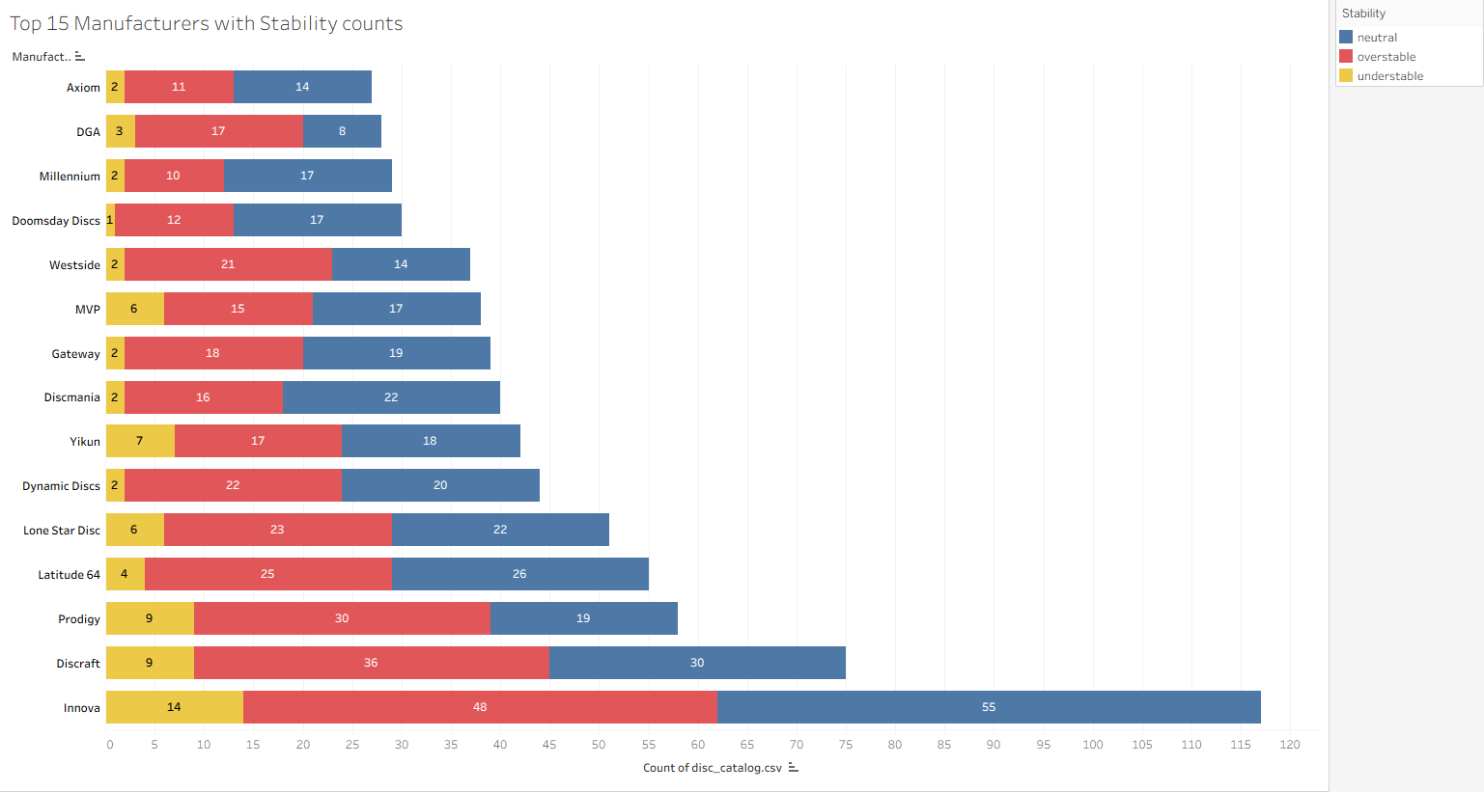

Figure 2
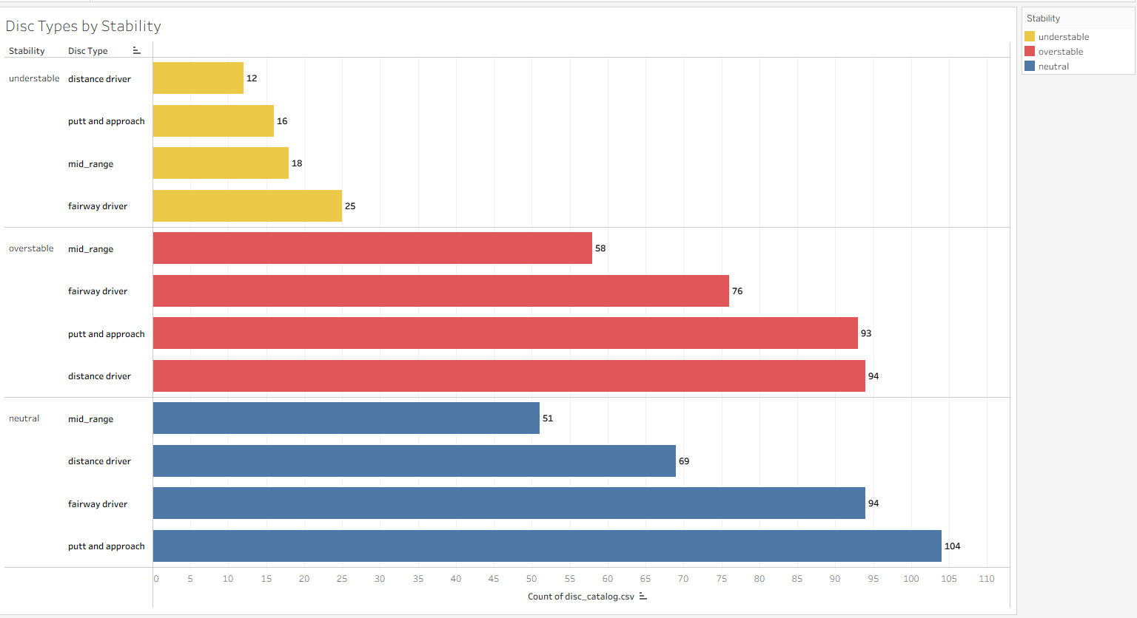
Figure 3
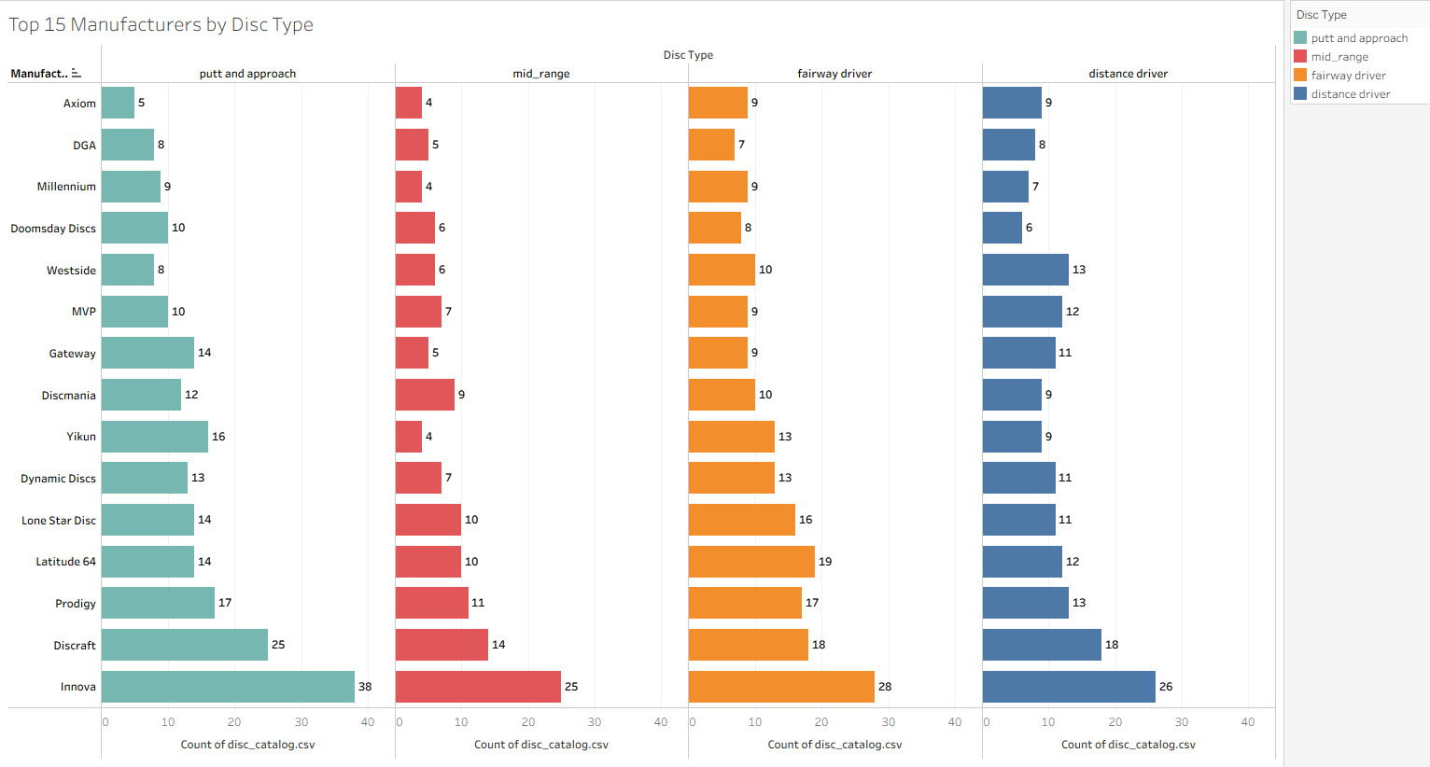

Figure 4
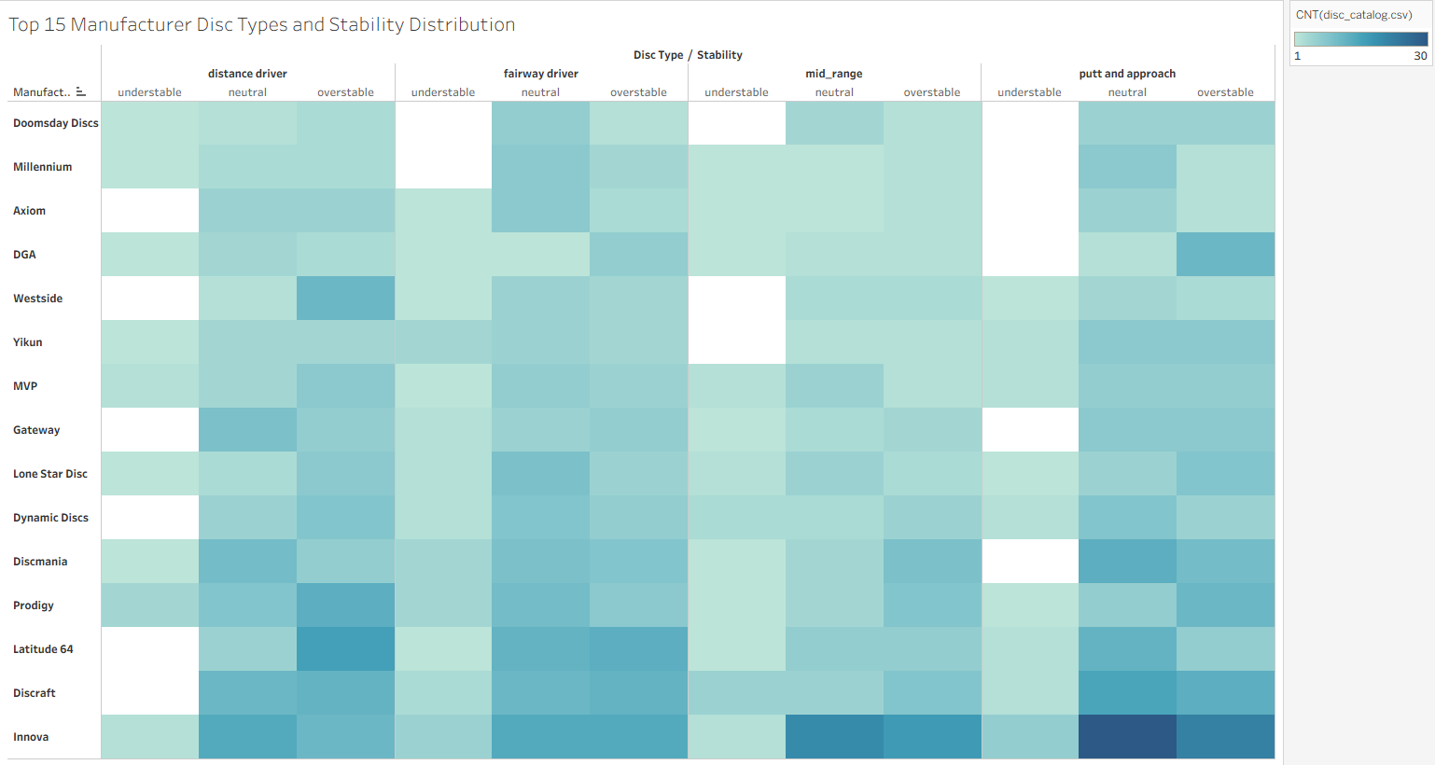
Figure 5
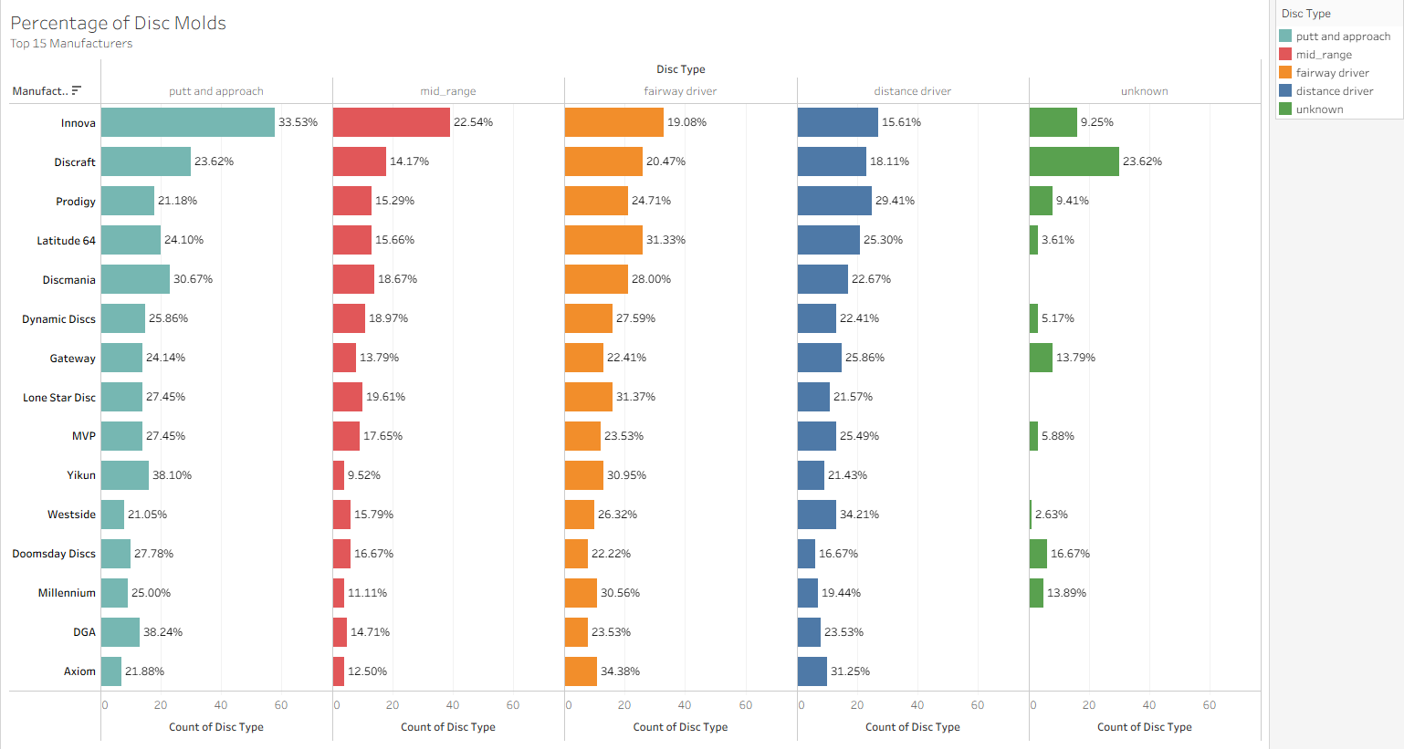

Figure 6
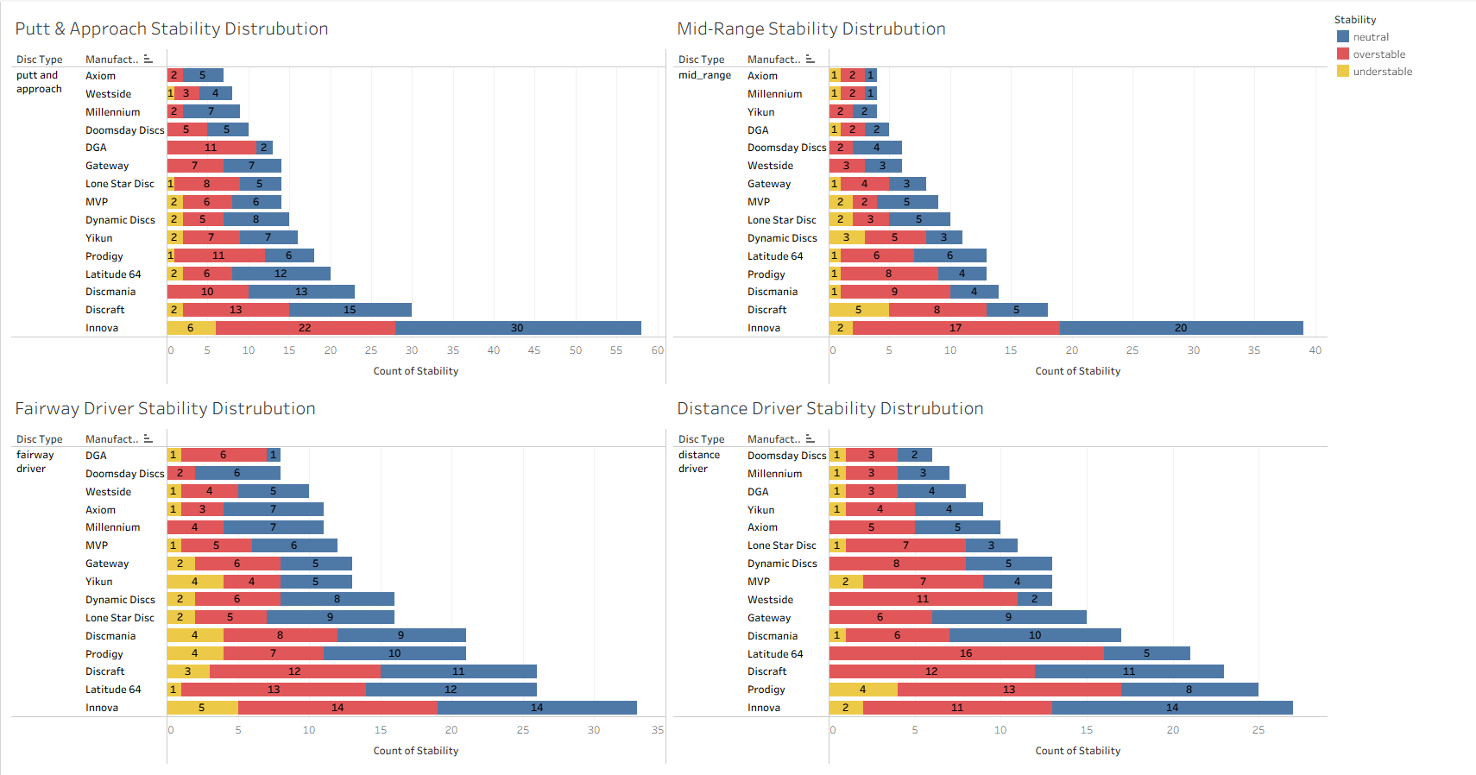

Key Findings
From the graphs we can determine that Innova has the strongest representation of neutral putt & approach discs (Figure 4). Innova also seems to be the manufacturer of more neutral disc options, almost double that of the next top manufacturer (figure 1). The least produced mold type overall is the understable distance driver. Understable is also the least produced stability amongst the top 15 manufacturers. The most produced disc mold type is the neutral putt & approach disc.
The top 3 of each category based on the percentage of each respective manufacture is as follows (figure 5):
Putt & Approach: DGA 38.24%, Yikun 38.1%, Innova 33.53%
Mid-Range: Innova 22.54%, LoneStar 19.61%, Dynamic Discs 18.97%
Fairway Drivers: Axiom 34.38%, LoneStar 31.37%, Latitude 31.33%
Distance Drivers: Westside Discs 34.21%, Axiom 31.25%, Prodigy 29.41%

Next Steps/Recommendations
The next steps of this data analysis would be to compile or use a top selling list for the last 5 years and to look at each manufacturer on an individual level. With the best-selling disc dataset, we could determine what disc mold category, and stability would be the best or safest to produce and continue producing. By inspecting individual manufacturers, we could determine what combination of flight numbers is missing in their respective product line.
Based on this initial analysis, the most competitive category is that of putt & approach. With 213 unique molds in this category, producing a unique disc here would be the most difficult. The category with the most opportunity for a unique disc is that of mid-ranges. Only 127 unique molds in this category means designing a disc that has potential to stand out might be easier.

Technology Used
- Python
  - Pandas, Requests, Time, Stats
- Tableau
- VS Code
- GitHub

Challenges & Limitations
The main challenge with this dataset is that it is only comprised of data we can receive via web-scraping. This is not the full list of discs in every type of plastic each manufacturer produces or in special editions of molds. The other main challenge of this dataset is that flight numbers are assigned by the manufacturer and there is not an industry standard that is used. Each manufacturer uses their own tests to determine the flight numbers. This might mean some molds fit into other categories based on another manufacturer's standards. Another challenge of this dataset is that discs all behave slightly differently based on weight, plastic, and a host of other external factors. This means one user might have a different experience with a particular disc mold than another user.

